Chalfont St Giles Gardens Association

Hints on Showing Fruit

- Pick as near to the time of the show as possible.
- Fruits should be fresh, uniform and characteristic in shape and colour, free from blemishes and damage from pests.
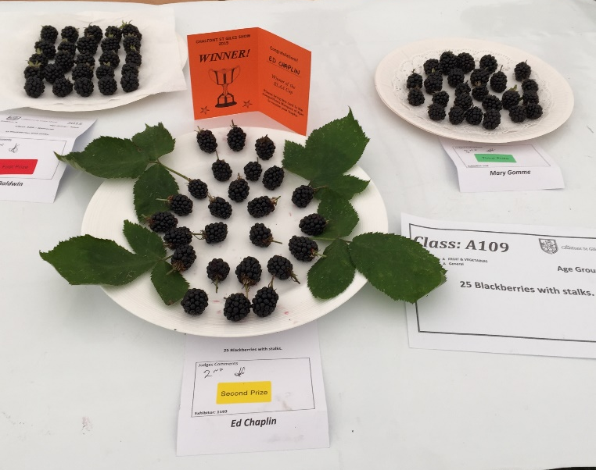
- Pick more than is required in the schedule so that you have some in reserve.
- Do not polish the fruits – leave their natural bloom.
- Handle fruits gently by their stalks and as little as little as possible.
- Package them carefully to take to the show – don’t pack too many in a container.
- Aim for neat, attractive presentation, as symmetrical as possible.

