Chalfont St Giles Gardens Association

Hints for the Floral Art Competition
- Your exhibit is your interpretation of the theme.
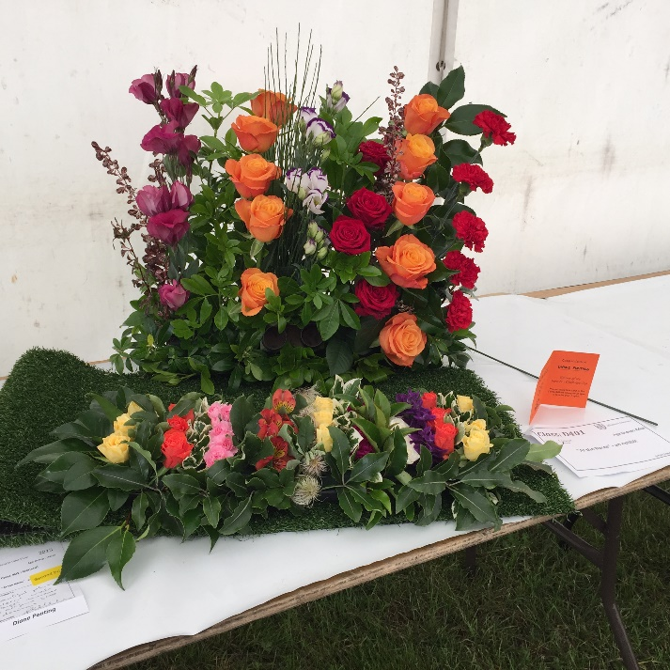
- All flowers and foliage must be displayed in water.
- The condition of the plants will be taken into account. Any brown leaves, fading petals or dead looking flowers will lose points.
- Be very strict with your measurements – every year exhibits are not judged because they exceed the maximum measurements shown in the schedule. Reduce your exhibit by a centimetre or two to be sure!
- Make sure your container is large enough to carry the amount of flowers and foliage you are intending to use.
- The base of the container should not be seen unless it is part of the design, ie a hat or shoe, etc.
- Before you decide on your design make a list of what you associate with the theme given – it might help you with your choice of flowers.
- Remember flowers/foliage must be the most dominant feature of the display. Don’t clutter it with too many accessories.

