Chalfont St Giles Gardens Association

Hints on Showing Vegetables

- Vegetables should be fresh, tender and without blemish or damage from pests.
- All vegetables should have their stalks on to prove they are homegrown.
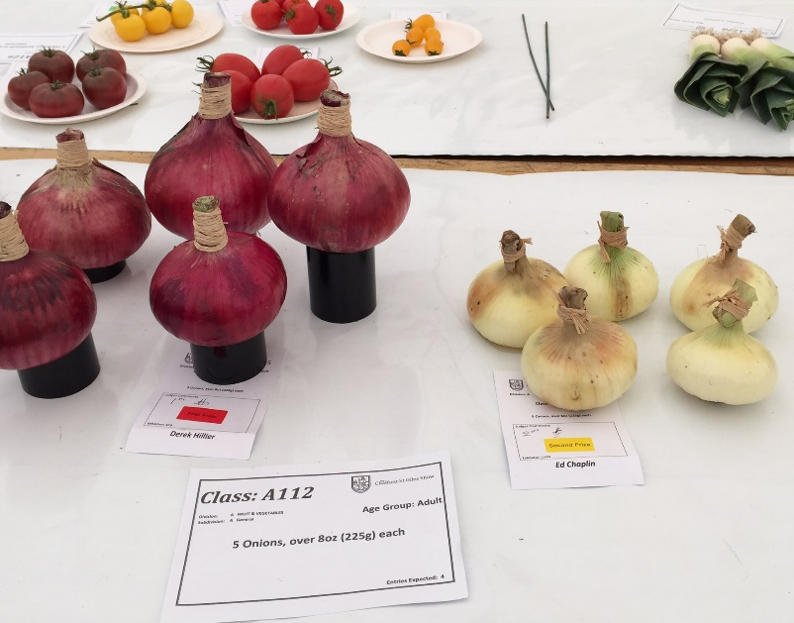
- Water the soil before lifting root vegetables to minimise damage to the root.
- Wash root vegetables carefully to remove soil – use soft cloth and plenty of water - brushing might damage the skin.
- Foliage for root vegetables should be trimmed to approximately 75 mm
- Other vegetables should be left with their natural bloom – do not wash or polish it away!
- Use a knife or scissors to carefully cut vegetables from a stem or vine and try to have each stem the same length.
- If possible, take one or two spares with you to the show in case of accidents.
- Vegetables should be staged as attractively as possible either direct on the table or on a plate if appropriate.

