Chalfont St Giles Gardens Association

Hints on Showing Flowers

- The ideal time to cut flowers is in the evening. Cut with as much stem as possible.
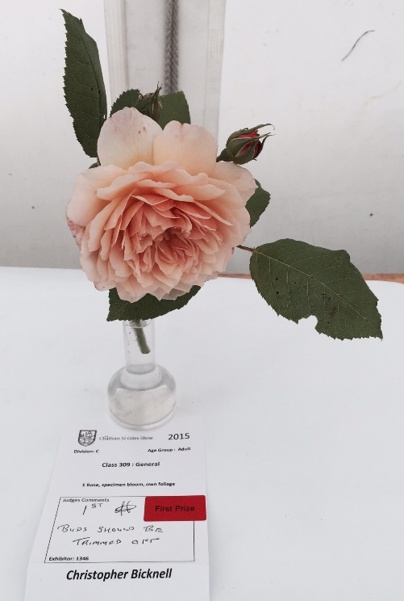
- Remove side shoots, leaves and unwanted buds and place in a container of clean deep water, overnight if possible.
- If necessary, use supports to help transport flowers and take spares just in case.
- Flowers should be shown with straight stems and ensure the stems are neither too long or too short.
- There should be no marks on either the petals or the leaves. Remove any damaged foliage or flowers.
- Blooms should face the same direction unless the class calls for “all round effect”.

