Making Space for Wildlife - John Tyler

Inside this Issue

* Making Space for Wildlife John Tyler
* Next Meeting – Outing to Stoke Poges Memorial Garden 16th June
* Members’ Open Gardens 15th June
* M’s Action Diary for May
* Green Gardening Tip of the Month
* Plant Sale – 14th May 2022
* Orchard Awareness Day 2nd June
* Plant Sales at Monthly Meetings
* Next Outing – Saturday, 30th July
* Other Dates for the Diary

A staggering 98% of wild flower meadows have been lost to monoculture farming and this means insect life has also been lost. John explained that gardeners can make a real contribution to our wildlife population by setting aside a portion of their garden and by careful planning of the planting and management of the whole plot.

Plants that benefit insects should include some that flower at different times of the year. Bumble bees forage early in the season so plant snowdrops, lungwort, comfrey and blackthorn. The elephant hawk moth is particularly fond of honeysuckle.

High summer plants include buddleia (pink is best), red valerian, biting stonecrop, sedum, comfrey and Marjoram. Important late flowering plants are Michaelmas daisies and ivy which has useful berries for birds as well as providing good winter cover.

Sloes, which are fruits of blackthorn, got a special mention not only as fruits for birds and an ingredient of slow gin but as a component of delicious chocolate – see recipe below.

Make a deliberate plan and include sunny alcoves to attract butterflies and other insects. If at all possible make a wild flower patch perhaps by changing a part of the lawn. Ideally you need to sow both spring and summer flowering areas – the spring patch can be cut in June and the Summer patch in August.

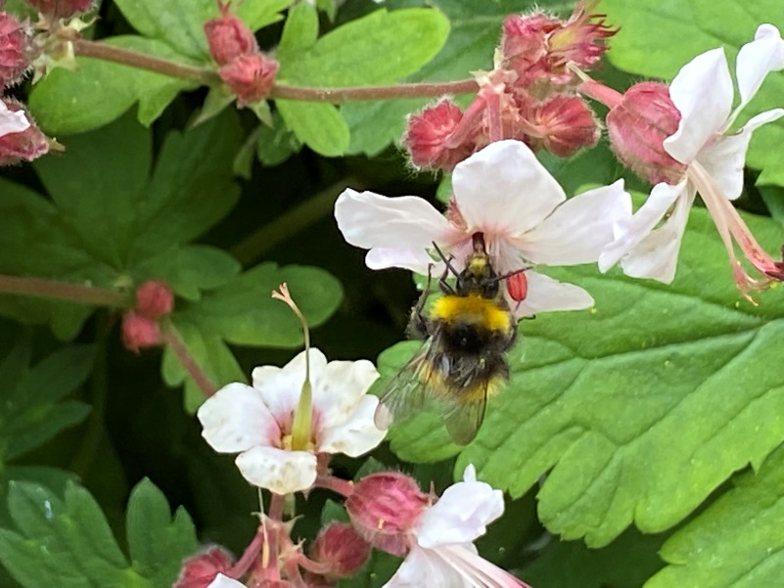A pond or even a container of water is a boon to wildlife as 75% of our ponds have been lost to development. It is important to top up with rainwater so best to collect and store water from a downpipe. Garden ponds often are the last refuge for frogs, toads and newts and it is important to note that toads need water two feet deep and newts need plenty of weed in the water. Think of adding a bog garden to your pond area.

Try to avoid spraying in your garden but leave it to the professionals ie natural control. Lacewings, hoverflies and ladybirds will eat aphids.

To encourage hedgehogs to visit your garden make gaps in your fence and encourage your neighbours to do the same. Bird nesting boxes must be high up and facing away from the sun. Bird feeders should have fine mesh and do put out niger seed for goldfinches. Bats have declined by 50% in 10 years largely due to modern buildings. Try putting up bat boxes to attract them for daytime sleeping and hibernation. A compost bin with slatted sides may attract snakes and slow worms who seek the warm shelter.

If everyone makes their garden more wildlife friendly we can go some way to restoring the levels of fascinating life around us. **Jan Bradley**

**John’s Sloe Chocolate**

Simply stone the sloes, melt a bar of dark chocolate, take it off the heat, mix in the sloes and leave to set in a greased container. Eat from the fridge. It has a delicious taste.

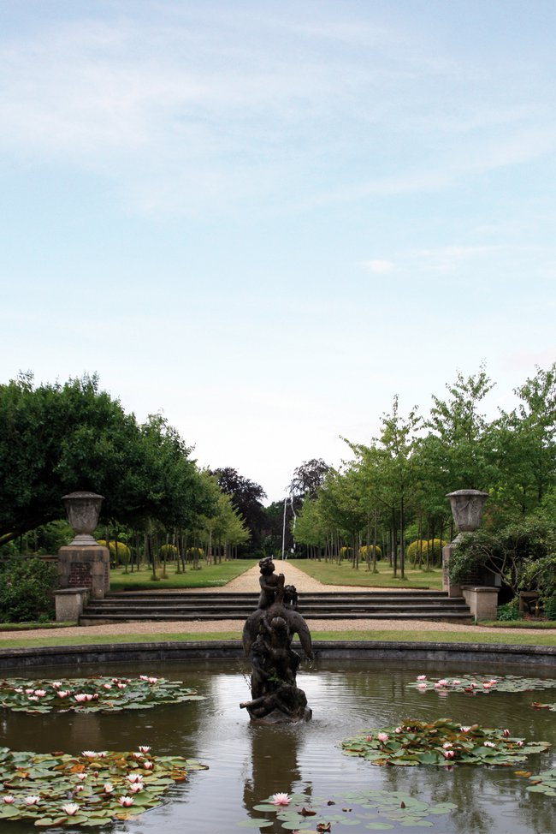Thursday, 16th June – Summer Outing to Stokes Poges Memorial Gardens

Church Lane, Stoke Poges, Slough, Berks, SL2 4NZ

**Please note: it is on the 3rd Thursday of the month on this occasion.**

After Frazi Cheesman’s talk about the Memorial Gardens at Stoke Poges, many members were keen to see them for themselves. So, we have arranged a vist there for our Summer Outing. The gardens contain formal and informal water features, a colonnade, rose garden, woodland, rock garden and open parkland with stunning views across the Capability Brown landscape and Repton bridge to Stoke Park.

The gardens will be open exclusively for our visit, Franzi and her colleague will give us a guided tour and then we’ll be free to wander before regrouping to enjoy prosecco or elderflower presse and strawberry tarts. We do need to know the numbers by Thursday 9th June and there will be a small charge of £6.00 per person for entry and the tour – the refreshments are being subsidised. **Please let Sam Patel know if you will be joining us so that we can buy the correct number of strawberry tarts!** 01494 875319[sumitrardpatel@outlook.com](mailto:sumitrardpatel@outlook.com)

Please make your own way there, parking is available. We will do our best to facilitate car shares, if necessary. Please let Briony or Sam know if you can offer a lift or would like one.

Members’ Open Garden – 15th June 2 – 5 pm

Roughwood, London Road, HP8 4ND

Under our new open gardens initiative being organised by Sam, Gill Aiken is the first to invite other CSGGA member’s to visit her garden. The aim of these visits is to give members the opportunity to exchange ideas, gain inspiration and make new friends. Gill has an interesting garden which has to cater for both sunny and shady aspects. Please join Gill on Wednesday, 15th June – all CSGGA members welcome, no need to book, just turn up!

M’s Action Diary for May

* Give sedums, phlox, campanulas and heleniums the “Chelsea Chop” by cutting some or all of the growth by a third for shorter, stronger, later flowering growth.
* Hard prune dononicums and pulmonarias to remove shots prone to mildew, encouraging new growth from the base. Once evergreen ceanothus have finished flowering cut back to flowered growth to green growth underneath. This will encourage new growth and also keep the plant in good shape.
* Lightly cut back alpines such as arabis and aubretia to shape them and promote new growth
* Clean garden furniture.
* Look out for lily beetle, viburnum beetle grubs, sawfly grubs on Solomon’s seal, vine weevil grubs and aphids and dispone.
* Put up a codling moth trap to protect apple and pear trees. One trap will serve five trees.

Green Gardening Tip – In praise of ivy

If you joined us for John Tyler’s talk, you will have heard him describe ivy as a wonderful but much maligned plant and I have to agree with him! Ivy, hedera helix, is an amazing plant and so useful to both gardeners and wildlife supporting at least 50 species. It will thrive where little else does, and with many different variegated cultivars, provide colour and interest throughout the year growing well as climber, groundcover, houseplant or as topiary According to the RHS, recent research shows ivy can help keep buildings cool in summer and less damp in winter. It’s also a source of wonderful foliage to cut for Christmas decoration, lasting longer than many other plants.

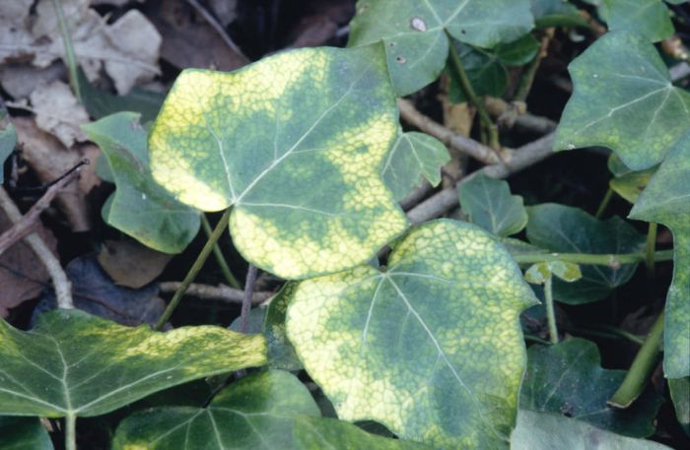Ivy provides birds with a place to nest and roost; pollinators with much needed nectar late in the year and birds with a feast when the berries appear in the winter. It also provides shelter for insects, bats and other small mammals.

Ivy uses trees and walls for support. According to John, Ivy does not damage trees. A young, healthy tree can lend that support only will only cause damage if it becomes more vigorous than the tree itself and its weight becomes too much or when it increases the wind resistance. Similarly, if a wall is sound then the ivy aerial roots cling to the outside of the brickwork or render. Research by English Heritage has shown that in some cases, ivy can help preserve stonework on old buildings.

So, why not make space in your garden for an ivy or two, and give nature a helping hand?

Our Annual Plant Sale

We were delighted with the number and quality of plants that arrived on the Village Green for our annual plant sale. After last year’s heavy rain, equally welcome was this year’s sunshine. Having learnt from the covid restrictions of last year, we again roped off the area and this made the queue, which formed not long after 9 o’clock, much more manageable.

Peter and Mary Bentall had been selling plants from their verge beforehand and together with the sale on the Village Green, we made not far short of a whopping £1200.00. This will increase as there are likely to be a few more pop up sales around the village. We are retaining the proceeds for the community orchard fund.

Many thanks to all those who donated and bought plants, or helped by hosting publicity boards, transporting tables, marshalling the queue or selling. We are most grateful to you all.

Another Cunning Plan – Plant Sales at Monthly Meetings

As the plant sale is so popular and so many members clearly enjoy propagating plants, we thought it might be a good idea to have a plant sale at the beginning of every meeting. Members who have a surplus of seedlings, cuttings, or plant divisions are invited to bring them along to the meetings held in the Hall. From July, we will have a table and an honesty box in the entrance of the Memorial Hall.

Plants should be clearly labelled with their common name and the variety, if you know it, flower colour and, if known, the sun requirements and the full grown height. You can either set a price or leave it to the buyer to decide how much they want to donate. Any plants that are not sold on the night should be taken back by the seller, but can be brought back to the next meeting. The proceeds will go towards worthy local causes. Initially this will be the community orchard, but we may choose to support a different charity every year.

Community Orchard

We will be holding an orchard awareness day on **Thursday 2nd June** in partnership with Milton’s Cottage 11.00 – 13.00. Fun activities for all ages and an orchard themed café, now in the Reading Room 14.00 – 16.30. If you can make a cake or other orchard themed treat or are willing to help on the day, we’d be delighted. Please let Briony or Sam know.

Our Next Outing

We have arranged a visit to the National Arboretum, near, Burton on Trent, and Hill Close Gardens in Warwick, for **Saturday, 30th July**. Cost £30 member, £35 for guests. If you wish to join us, please contact Eleanor for the details.

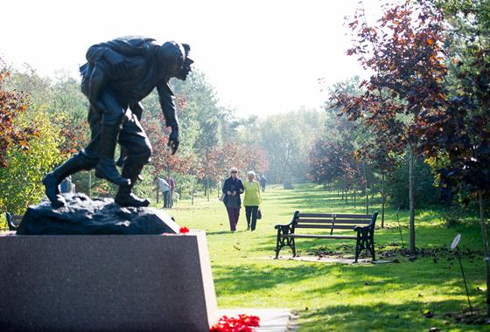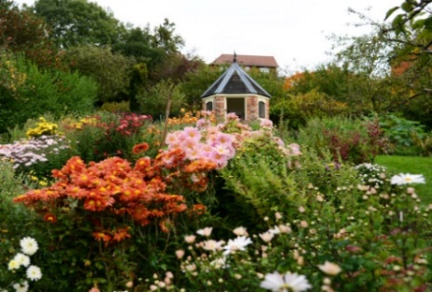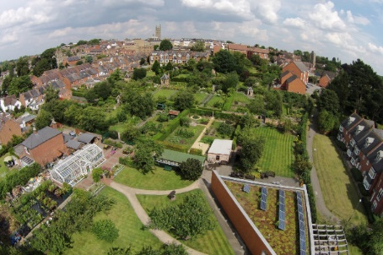

**Your Committee**

**Chairman and Membership Secretary:**

Briony Wickenden Mulberry House, 54 Milton Fields, Chalfont St Giles, HP8 4EP 01494879482 [brionywickendke@hotmail.com](mailto:brionywickendke@hotmail.com)

**Secretary:** Jan Bradley, 23 The Lagger, Chalfont St Giles, HP8 4AA 01494 874704 [janbradley4@btinternet.com](mailto:janbradley4@btinternet.com)

**Treasurer:** Margaret Dykes, 4 Roughwood Fields, Roughwood Lane, Chalfont St Giles, HP8 4AA 01494 874511 [margaretrdykes@btinternet.com](mailto:margaretrdykes@btinternet.com)

**Committee Members:**

Mary Holloway 01494 875793

Caroline Jackson 01494 876685

Eleanor O’Connor 01494 875646

Sumitra Patel 01494 875319

New Committee members are always welcome. We are a friendly bunch! Please contact a committee member to find out more if you’re interested in joining us.

**Dates for the Diary**

**Thursday, 2nd June - Orchard Awareness Day** 11.00 – 13.00 at Milton’s Cottage for fun activities for all the family and 2.00 – 4.30 at the Reading Room, for an Orchard Café.

**Sunday, 5th – Thursday, 9th June** – **Gardens Association Holiday** to the Peak District.

**Wednesday 15th June Gill Aikens Open Garden** 2-5

Roughwood, London Road, HP8 4ND

**Thursday, 16th June – not the usual 2nd Thursday Evening Outing to Stoke Poges Memorial Garden,** Church Lane, Stoke Poges SL2 4NZ 18.00 Members to make their own way there but we might be able to help facilitate car shares.

**Saturday, 30th July**

Visit to the National Arboretum and Hill Close Gardens. Details from Eleanor O’Connor.