Chalfont St Giles Gardens Association

The Gardens & Heritage Houses

Of Suffolk

Itinerary
It has been necessary to make some changes to the itinerary as some venues are choosing to remain closed for the foreseeable future. The running order of the places to be visited has also been amended from the original literature to accommodate opening days and group availability at some sites. These changes have been made in conjunction and agreement with your group organiser and have been chosen to offer a good mix of visits and free time that we hope you will all enjoy:-

Day 1:
We depart from our designated pick-up point and travel to Suffolk, please see the following Client Information pages for further details.
En route we visit the Forgotten Gardens of Easton Lodge for a garden tour of this idyllic haven which is Historic England Grade II registered and showcases Harold Peto's grand designs and treehouse, now rebuilt in the old oak tree. Peto's Italian garden is always colourful and the walled kitchen garden is well stocked with fruit and vegetables. There are ten national or regional champion trees and in the Glade the trees enclose the Stumpery and Japanese garden.
We then visit Marks Hall Gardens and Arboretum where we enjoy a guided tour. The Marks Hall collection is planted on a geographical theme with plants from the temperate regions of the world grouped together. There are areas representing Europe, Asia, North America and the Southern Hemisphere, set in more than 200 acres of historic landscape providing interest and enjoyment throughout the year.
We then continue to the 4* Stoke by Nayland Hotel, located in the countryside approximately ten miles north of Colchester, where we stay for four nights on a half board basis.
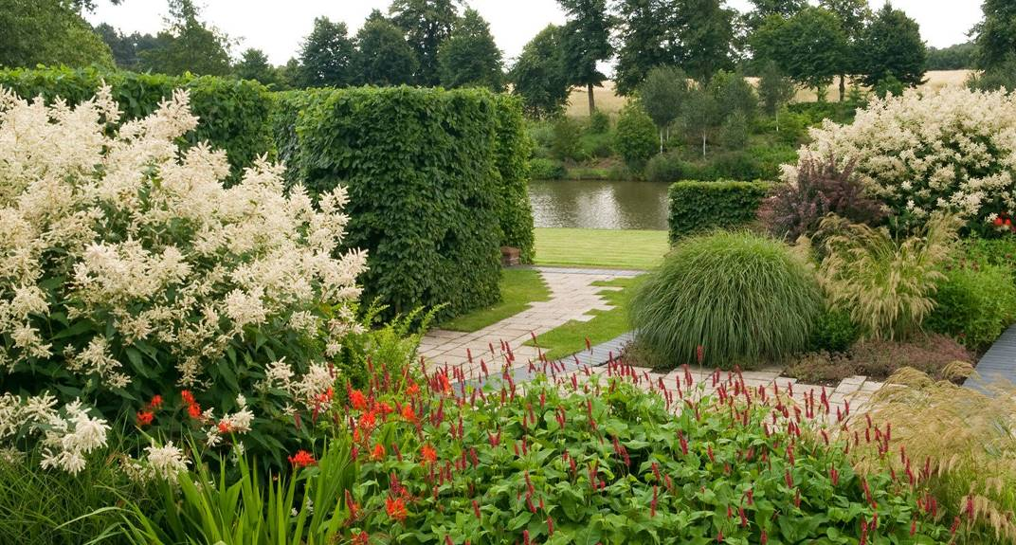
Marks Hall Gardens and Arboretum

Day 2
Today, after meeting our Blue Badge guide, we travel to Southwold, a charming seaside town on the Suffolk Heritage Coast, where we spend the morning at leisure. Whilst in Southwold, for those who have pre-booked, we enjoy an optional guided tour at the Adnams Brewery. Situated in the heart of Southwold, Adnams have been brewing since 1872 and the tour explores Adnam’s history and gives an insight into what makes Adnam’s special. At the end of the tour visitors are offered the opportunity to taste the product. We then have free time for lunch in Southwold.
This afternoon we continue to Ipswich where a guided tour introduces us to sights such as the Town Hall and the Ancient House. The remainder of the afternoon is then at leisure in Ipswich to explore as we wish.

Day 3:
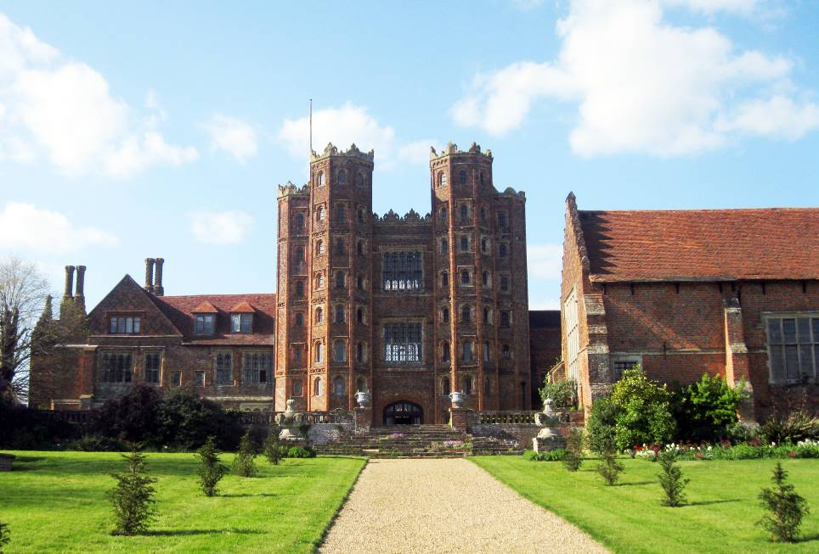
This morning, with our Blue Badge guide, we visit Layer Marney Tower, a statement house of grand design set in beautiful gardens. The tallest Tudor gatehouse in the country, Layer Marney Tower was built in the 1520's by Lord Marney, friend to both Henry VII and Henry VIII. Decorated with ornate terracotta, Layer Marney has been a family home for over 500 years. During our guided tour we enjoy included tea and traybake.
Layer Marney Tower
We then spend some time at leisure for lunch in Colchester, before our afternoon visit to the nearby Green Island Gardens. Professionally designed by its owner Fiona Edmond, the land is laid out as a series of structured gardens displaying a huge range of unusual trees, shrubs, perennials, and bulbs.

Day 4:
Accompanied again by our Blue Badge guide, we visit Fullers Mill Garden, an enchanting and tranquil waterside and woodland garden, situated on the banks of the River Lark at West Stow in Suffolk. It combines a beautiful site of light dappled woodland with a fabulous collection of rare and unusual shrubs, perennials, lilies and marginal plants, collected over the course of 50 years by the creator of the garden Bernard Tickner MBE.
We spend the afternoon at Helmingham Hall Gardens, and have free time for lunch here during our visit. The Tollemache family enjoy sharing their passion for the beautiful gardens, opening them to visitors throughout the summer. Helmingham Hall boasts a relaxed atmosphere for visitors to enjoy the serenity and tranquillity of the gardens as you lose yourself in the plethora of colour, scents and history on offer.

Day 5:
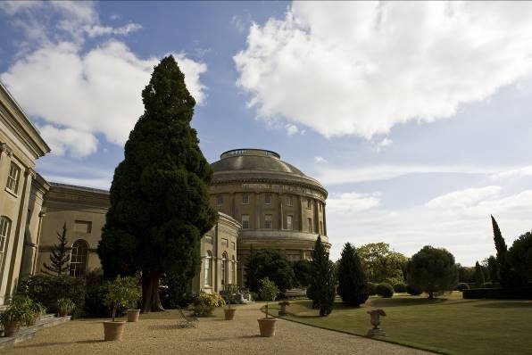
After checking out of our hotel and en route home we visit the National Trust’s Ickworth House, located in 70 acres of stunning gardens and 1,800 acres of idyllic ‘Capability’ Brown parkland. Dominated by its huge central Rotunda dating from 1795, Ickworth is home to a fine collection of Old Master paintings, silver and Regency furniture.
Ickworth House
After free time for lunch and to enjoy the Ickworth estate we visit Wyken Hall Gardens and Vineyard near Bury St Edmunds, home to a picturesque array of topiary, herbs, roses, and fruit trees.
We then continue our journey back to our original pick-up point in Chalfont St Giles.

